# High level use case

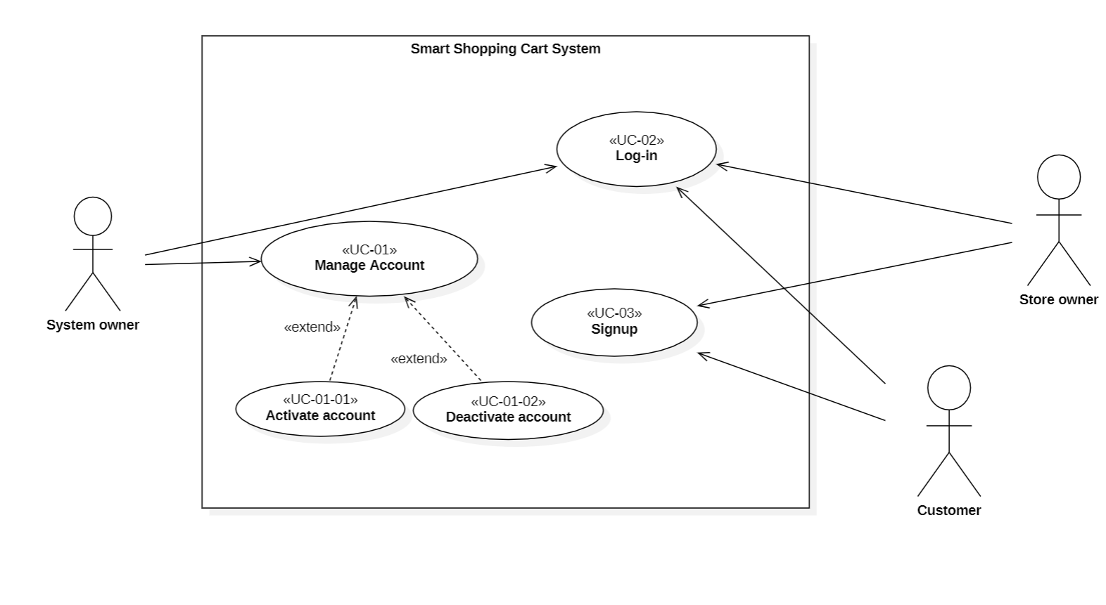

# Use Case

# Manage Account

|  |  |
| --- | --- |
| Use case Id | UC-01 |
| Use case title | Manage Account |
| Description | System owner deactivates/activates an account |
| Actors | System owner |
| Primary condition | System owner is logged in |
| The flow of events | 1. The system owner accesses the account management sections from the admin dashboard 2. The system displays list contains all users 3. The system owner will choose user he wants to deactivate/activate his account 4. The system displays user info 5. The system owner use deactivated/activated selected user and click on save 6. The system displays success message |
| Alternative scenarios |  |
| Exception scenarios |  |
| Post condition | The account selected is deactivated and all changes saved in database |
| Use case Id | UC-01 |
| Use case title | Account management |
| Description | System owner create an account for store owner or deactivate account |
| Actors | System owner |
| Primary condition | System owner is logged in |
| The flow of events | 1. The system owner accesses the account management sections from the admin dashboard 2. The system displays list contains all stores owners and with options for adding or removing store owner 3. If system owner press on add store owner button 4. The system displays form contains fields (first name, last name, email, ...etc.) 5. The system owner fills in all fields and clicks on save 6. The system checks if all fields are completed 7. The system validates data in all fields 8. The system sends a link to store owner for setting his password with displaying a message “We’ve sent message to you for setting his password” 9. If system owner wants deactivate a specific store owner: 10. The system owner will choose store owner he wants to deactivate his account 11. The system displays store owner info 12. The system owner use deactivated selected store owner and click on save 13. The system displays success message |
| Alternative scenarios | A1: start at step 6 in the main scenario If the system owner leaves one or more fields are required:   1. The system displays an error message indicating that field is required. 2. The system owner will complete fields and press on create account.   And flow will return to step 5. |
| Exception scenarios |  |
| Post condition | Changes made to store owner account saved to the system |

## Sequence diagram

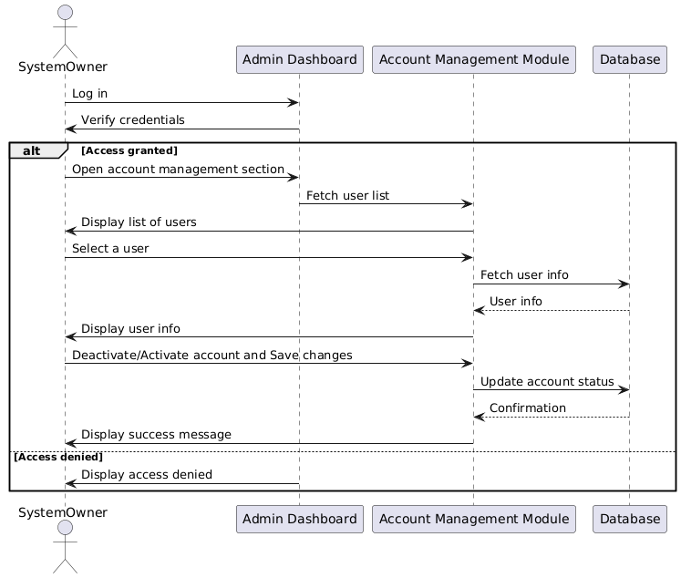

## Activity diagram

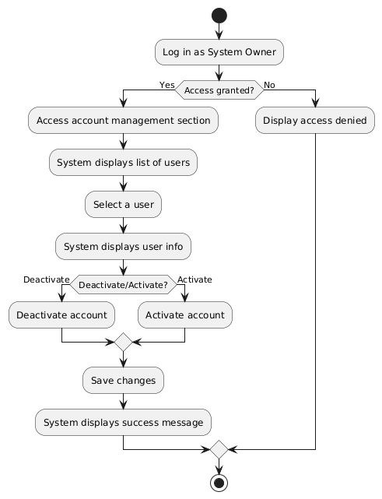

# Log-in

|  |  |
| --- | --- |
| Use case Id | UC-02 |
| Use case title | Log-in |
| Description |  |
| Actors | Store Owner |
| Precondition | The store owner account exists, and login credentials (username and password) have been provided by the system admin. |
| The flow of events | 1. The Store Owner opens the login page. 2. The system prompts for the username and password. 3. The Store Owner enters credentials and submits the form. 4. The system validates the credentials. 5. If valid, the system grants access to the dashboard. |
| Alternative scenarios | A1: start at step 4, If the credentials are invalid:   1. The system displays an error message and prompts the Store Owner to re-enter the credentials.   And the flow will return to step 3. |
| Exception scenarios |  |
| Post condition | Store owner is logged in |

## Activity diagram

## Sequence diagram

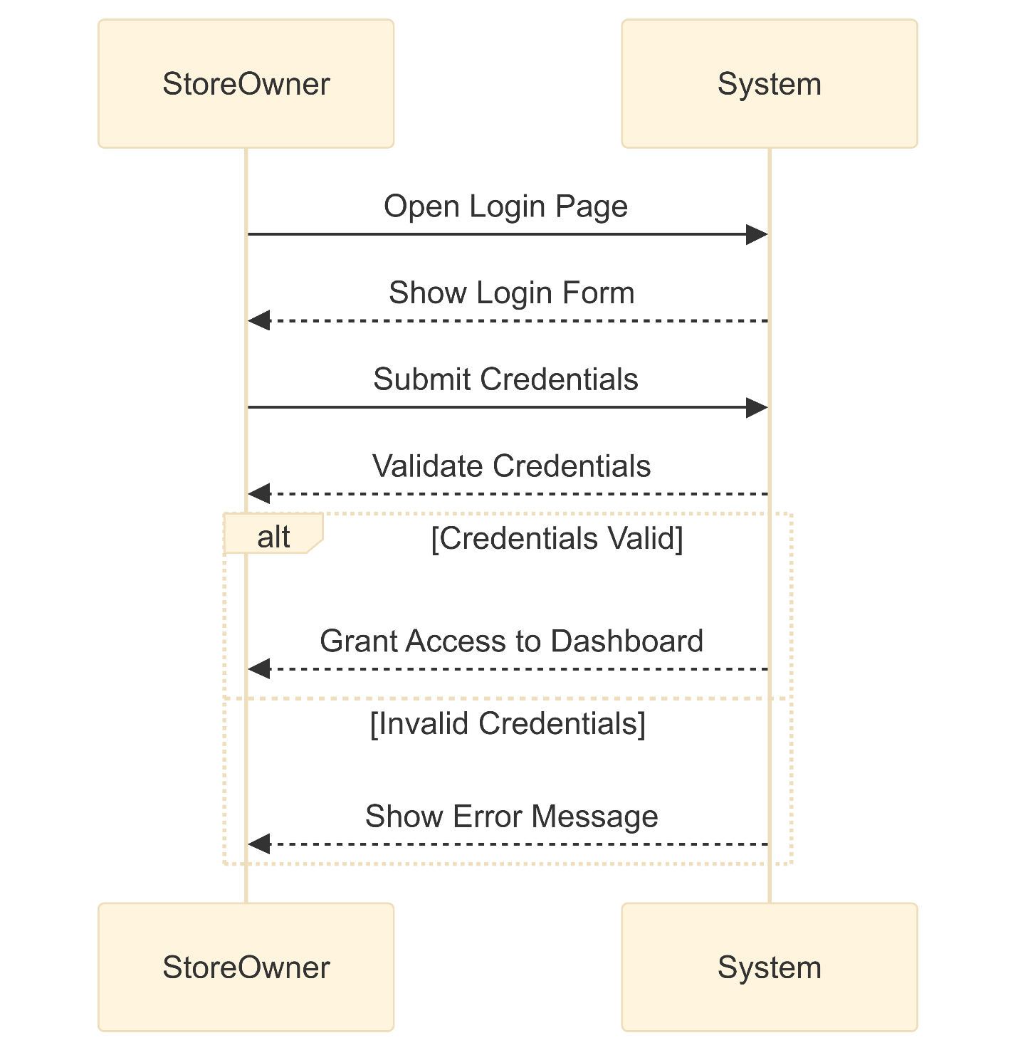

# Sign-up

|  |  |
| --- | --- |
| Use case Id | UC-03 |
| Use case title | Sign-up |
| Description | A new user creates an account with the system. |
| Actors | Store owner, Customer |
| Primary condition | The user has navigated to the signup page. |
| The flow of events | 1. The user selects type of account (customer, store owner) from a dropdown menu 2. The system shows user a form. 3. The user enters their desired info (first name, last name, email address, password, …, etc.) in the provided fields and press on create account in form. 4. The system checks if all fields are completed. 5. The system verifies if the data is entered by user are valid. 6. If data is valid the system displays a success message indicating that the account has been created successfully. |
| Alternative scenarios | A1: start step 3 in the main flow, If the  user leaves one or more fields are required:   1. The system displays an error message indicating that field is required. 2. The user will complete fields and press on create account   And the flow will return to step 4.  A2: start step 5 in the main flow, If the entered email address is already existed:   1. The system displays an error message and prompts the user to choose a different an email. 2. The user will reenter an email and press create account.   And the flow will return to step 4  A3: start step 5 in the main scenario if the user entered a weak password:   1. The system shows user message the password must be at least 8 characters. 2. The user reenters password   And flow will return to step 3. |
| Exception scenarios |  |
| Post condition | A new user account is created in the system database with the provided information. |

## Sequence diagram

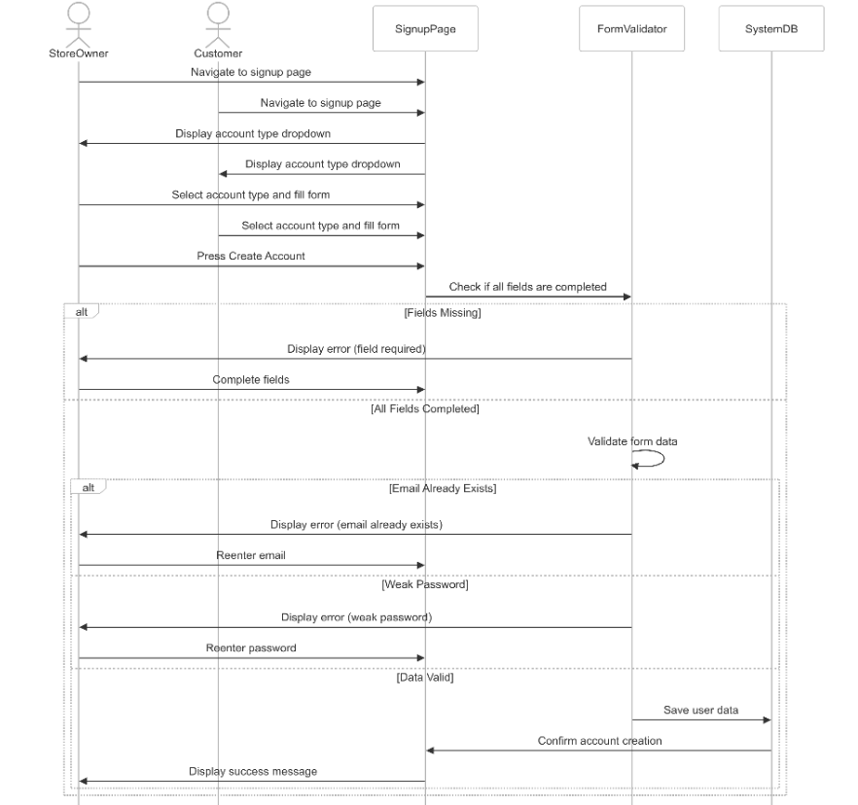

## Activity diagram

